**PostgreSQL Assignment**

**CLUBDATA**

**String Operations**

**1.[Format the names of members](https://pgexercises.com/questions/string/concat.html)**

select surname || ', ' || firstname as name from cd.members

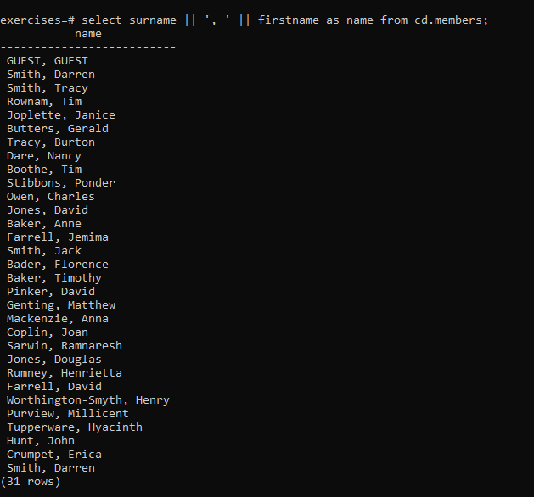

**2.[Find facilities by a name prefix](https://pgexercises.com/questions/string/like.html)**

select * from cd.facilities where name like 'Tennis%';

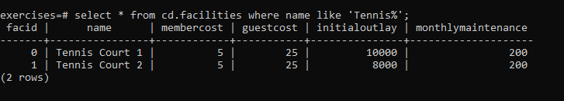

**3.[Perform a case-insensitive search](https://pgexercises.com/questions/string/case.html)**

select * from cd.facilities where upper(name) like 'TENNIS%';

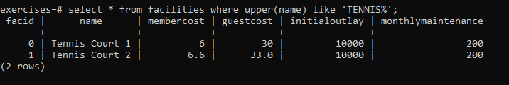

**4.[Find telephone numbers with parentheses](https://pgexercises.com/questions/string/reg.html)**

select memid, telephone from cd.members where telephone similar to '%[()]%';

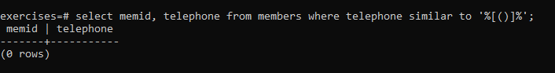

**5.[Pad zip codes with leading zeroes](https://pgexercises.com/questions/string/pad.html)**

select lpad(cast(zipcode as char(5)),5,'0') zip from cd.members order by zip

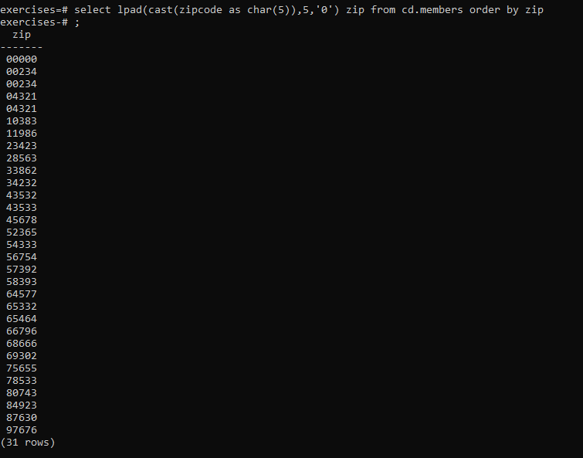

**6.[Count the number of members whose surname starts with each letter of the alphabet](https://pgexercises.com/questions/string/substr.html)**

select substr (mems.surname,1,1) as letter, count(*) as count from cd.members mems group by letter order by letter

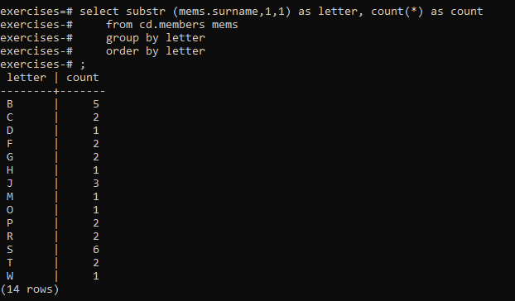

**7.[Clean up telephone numbers](https://pgexercises.com/questions/string/translate.html)**

select memid, regexp_replace(telephone, '[^0-9]', '', 'g') as telephone

from cd.members

order by memid;

